|  |
| --- |
| Formsteel |
| Structural Report |
| PS1 – Structural calculation and design report |

|  |
| --- |
| Formsteel  4-25-2019 |



[TOC]

# Geometry

## Basic geometry

Width B = [GableWidth] m

Length L = [Length] m

Height H1 = [WallHeight] m

~~Height H~~~~2~~ ~~= 4.48 m~~~~2~~

Roof Pitch α = [RoofPitch_deg]deg

Girt spacing Bg = [GirtDistance] m

Purlin spacing Bp = [PurlinDistance] m

Wind post spacing Bwp = [ColumnDistance] m

Rafter length 9.423 m

Toto by somasidal do tabulky, aby to bolo peknenaformatovane

Pismenkazakladnehofontu by malibyt co najmensie a citatelne “10”???

Pointa je vsetkonahustittak aby smemali co najmenejstran a co najhutnejsie data.

## Structural model in 3D environment

Orezatbieleokrajeobrazka aby bol co najvacsi. Este samusimetroskupohrat s farbami aby to nabielompozadivyzeralolepsie. Asibudemepotrebovat 2 sadyfarieb pre 3D grafikuaine pre export.

[3DModelImage_MemberSolidModel]

[3DModelImage_MemberCenterlines]

# Material properties

[MaterialProperties]

# Cross-sections

[CrossSections]

# Member types

[MemberTypes]

# Load

## Basic Parameters

[BasicLoadParameters]

Location: [Location]

Design life: [DesignLife_Value]

Importance level: [ImportanceClass]

Annual probability of exceedance SLS: [AnnualProbabilitySLS]

Return period SLS: RSLS = [R_SLS] years

Site elevation E = [SiteElevation] m

## Dead Load

[DeadLoad]

Wall cladding load g c.w = [CCalcul_1170_1.DeadLoad_Wall] kN/m2

Roof cladding load g c.r = [CCalcul_1170_1.DeadLoad_Roof] kN/m2

Additional wall load g a.w = [AdditionalDeadActionWall] kN/m2

Additional roof load g a.r = [AdditionalDeadActionRoof] kN/m2

Total wall load g t.w = [CCalcul_1170_1.DeadLoadTotal_Wall] kN/m2

Total roof load g t.r = [CCalcul_1170_1.DeadLoadTotal_Roof] kN/m2

## Service load

Todo – if necessary

## Live / Imposed Load

Roof live load q l.r = [ImposedActionRoof] kN/m2

[ImposedLoad]

## Snow Load

[SnowLoad]

Annual probability of exceedance ULS: [AnnualProbabilityULS_Snow]

Return period RULS.S = [R_ULS_Snow] years

Snow elevation region: [CCalcul_1170_3.eSnowElevationRegion]

Ground snow load sg.ULS= [CCalcul_1170_3.s_g_ULS] kN/m2

Ground snow load sg.SLS= [CCalcul_1170_3.s_g_SLS] kN/m2

Roof exposure category [ExposureCategory]

Exposure factor Ce = [CCalcul_1170_3.C_e]

Factor μ1 = [CCalcul_1170_3.Nu1_Alpha1]

Factor μ2 = [CCalcul_1170_3.Nu2_Alpha1]

Roof snow load sULS= [CCalcul_1170_3.s_ULS] kN/m2

Roof snow load sSLS= [CCalcul_1170_3.s_SLS] kN/m2

## Wind Load

[WindLoad]

Annual probability of exceedance ULS: [AnnualProbabilityULS_Wind]

Return period RULS.W = [R_ULS_Wind] years

Wind region [EWindRegion]

Terrain category [TerrainCategory]

Reference height z = [CCalcul_1170_2.z] m

Average structure height h = [CCalcul_1170_2.h] m

Regional 3s gust wind speed VR.ULS = [CCalcul_1170_2.V_R_ULS] m/s

Regional 3s gust wind speed VR.SLS = [CCalcul_1170_2.V_R_SLS] m/s

Terrain/height multiplier Mz.cat= [CCalcul_1170_2.M_z_cat]

Shielding multiplier Ms = [CCalcul_1170_2.M_s]

Topographic multiplier Mt = [CCalcul_1170_2.M_t]

Wind direction multiplier Md = [CCalcul_1170_2.fM_D_array_values_9[0]]

Site wind speed Vsit,β.ULS= [CCalcul_1170_2.V_sit_ULS_Theta_9[0]] m/s

Site wind speed Vsit,β.SLS= [CCalcul_1170_2.V_sit_SLS_Theta_9[0]] m/s

Design wind speed Vdes,θ.ULS=[CCalcul_1170_2.V_des_ULS_Theta_4[0]] m/s

Design wind speed Vdes,θ.SLS= [CCalcul_1170_2.V_des_SLS_Theta_4[0]] m/s

Density of air ρair = [CCalcul_1170_2.Rho_air] kg/m3

Dynamic response factor Cdyn = [CCalcul_1170_2.C_dyn]

Basic wind pressure pb.ULS = [CCalcul_1170_2.p_basic_ULS_Theta_4[0]] kN/m2

Basic wind pressure pb.SLS = [CCalcul_1170_2.p_basic_SLS_Theta_4[0]] kN/m2

## Seismic Load

Equivalent static method parameters

[SeismicLoad]

Annual probability of exceedance ULS: [AnnualProbabilityULS_EQ]

Return period RULS.EQ = [R_ULS_EQ]

Site subsoil class [ESiteSubSoilClass]

Fault distance Dmin = [FaultDistanceDmin] km

Fault distance Dmax = [FaultDistanceDmax] km

Zone factor Z = [ZoneFactorZ]

Contributing weight Gtot.x= [CCalcul_1170_5.G_tot_x] kN

Contributing weight Gtot.y= [CCalcul_1170_5.G_tot_y] kN

Natural period along X-direction Tx = [CCalcul_1170_5.PeriodAlongYDirectionTx] s

Natural period along Y-direction Ty = [CCalcul_1170_5.PeriodAlongYDirectionTy] s

Spectral shape factor Ch(Tx) = [CCalcul_1170_5.SpectralShapeFactorChTx]

Spectral shape factor Ch(Ty) = [CCalcul_1170_5.SpectralShapeFactorChTy]

**ULS**

Structural ductility factor μ = [CCalcul_1170_5.Nu_ULS]

Structural performance factor Sp = [CCalcul_1170_5.S_p_ULS_strength]

Near-fault factor N(Tx,D) =[CCalcul_1170_5.N_TxD_ULS]

Elastic site hazard spectrum C(Tx) = [CCalcul_1170_5.C_Tx_ULS]

Factor kμ(Tx) = [CCalcul_1170_5.k_Nu_Tx_ULS]

Horizontal design action coefficient Cd (Tx) = [CCalcul_1170_5.C_d_T1x_ULS_strength]

Horizontal static force Vx = [CCalcul_1170_5.V_x_ULS_strength] kN

Near-fault factor N(Ty,D) =[CCalcul_1170_5.N_TyD_ULS]

Elastic site hazard spectrum C(Ty) = [CCalcul_1170_5.C_Ty_ULS]

Factor kμ(Ty) = [CCalcul_1170_5.k_Nu_Ty_ULS]

Horizontal design action coefficient Cd (Ty) = [CCalcul_1170_5.C_d_T1y_ULS_strength]

Horizontal static force Vy = [CCalcul_1170_5.V_y_ULS_strength] kN

**SLS**

Structural ductility factor μ = [CCalcul_1170_5.Nu_SLS]

Structural performance factor Sp = [CCalcul_1170_5.S_p_SLS]

Near-fault factor N(Tx,D) =[CCalcul_1170_5.N_TxD_SLS]

Elastic site hazard spectrum C(Tx) = [CCalcul_1170_5.C_Tx_SLS]

Factor kμ(Tx) = [CCalcul_1170_5.k_Nu_Tx_SLS]

Horizontal design action coefficient Cd (Tx) = [CCalcul_1170_5.C_d_T1x_SLS]

Horizontal static force Vx = [CCalcul_1170_5.V_x_SLS] kN

Near-fault factor N(Ty,D) =[CCalcul_1170_5.N_TyD_SLS]

Elastic site hazard spectrum C(Ty) = [CCalcul_1170_5.C_Ty_SLS]

Factor kμ(Ty) = [CCalcul_1170_5.k_Nu_Ty_SLS]

Horizontal design action coefficient Cd (Ty) = [CCalcul_1170_5.C_d_T1y_SLS]

Horizontal static force Vy = [CCalcul_1170_5.V_y_SLS] kN

# Load Cases

[LoadCases]

# Load Combinations

[LoadCombinationsULS]

|  |  |  |  |  |
| --- | --- | --- | --- | --- |
| **Name** | **Limit State** | **Load Cases** | **Combination Key** | **Formula** |

[LoadCombinationsSLS]

|  |  |  |  |  |
| --- | --- | --- | --- | --- |
| **Name** | **Limit State** | **Load Cases** | **Combination Key** | **Formula** |

# Member design

[MemberDesign]

# Joint Design

[JointDesign]

## Member type: Main Column

Zobrazit pre kazdytypcombponenty so zaskrtnutym Design detailyposudkuspojov z UC_JointDesign

TODO - Potrebovali by smetuvlozitobrazokspojanazaciatku a nakoncipruta v 3D alebo 2D.

Pre 2D by smemohlipouzit to canvas zo System Component Viewer

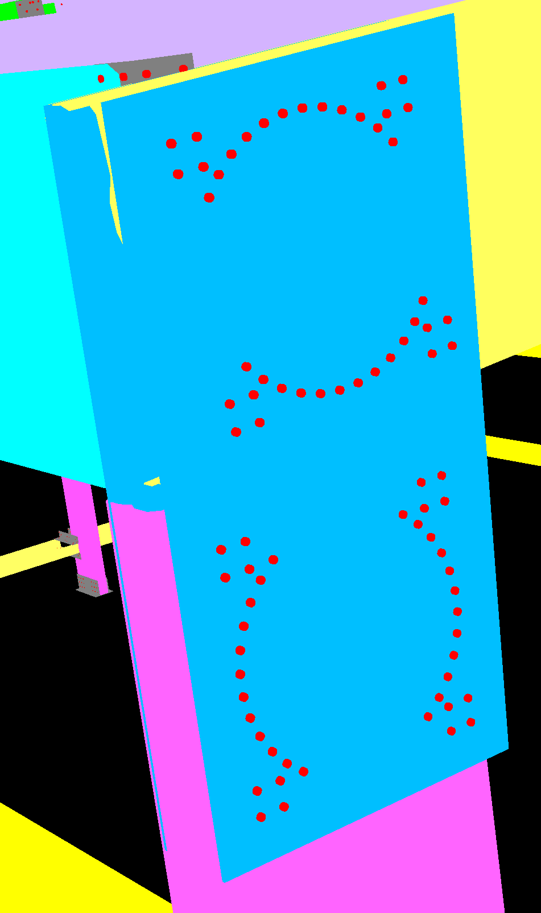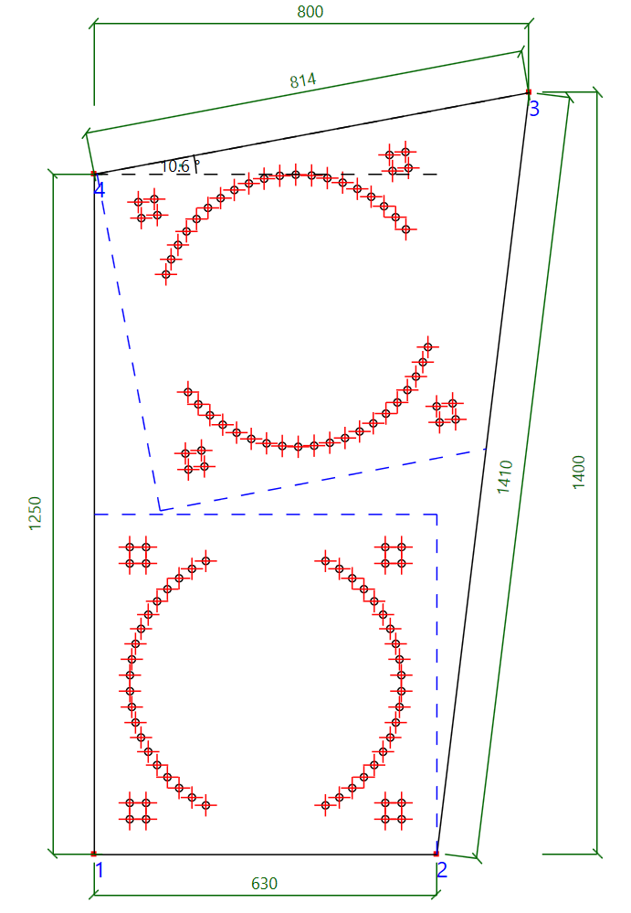

# Footing Design

TODO (oddelitvysledky od joint design)